**Practicum Report**

Job sheet 4

Selection 1

Experiment & Assignment



MUHAMMAD BAIHAQI AULIA ASY’ARI

2241720145

CLASS 1I (INTERNATIONAL)

INFORMATICS ENGINEERING­­

INFORMATICS TECHNOLOGY

STATE POLYTECHNIC OF MALANG

Contents

Laboratory Experiment 3

Experiment 1 3

Questions! 7

Answer! 7

Experiment 2 9

Question! 11

Answer! 11

Experiment 3 12

Question! 14

Answer! 14

Experiment 4 16

Question! 18

Answer! 18

Assignment 19

Answer! 20

# Laboratory Experiment

## Experiment 1

1. Observe the flowchart! 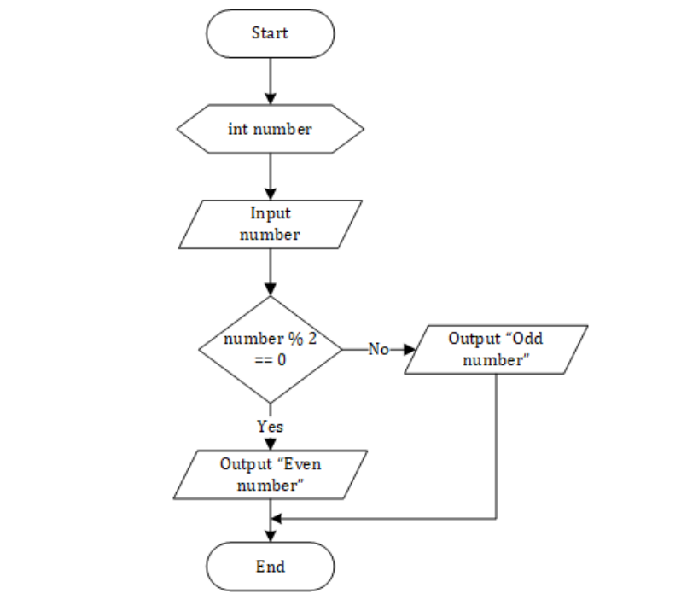The flowchart is used to determine odd or even numbers, then we will make the program based on the flowchart.
2. Open a text editor. Create a new file, name it **Selection1.java**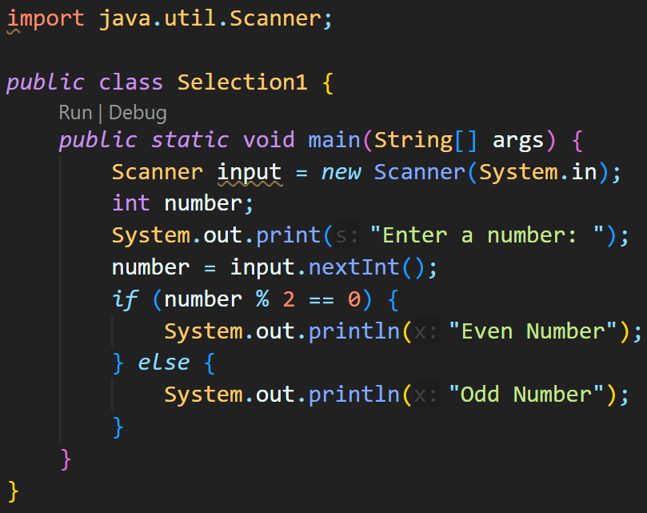
3. Write the basic structure of the Java programming language which contains the **main()** function
4. Add the **Scanner** library. Write the following code at the top **outside the class** 
5. Make a Scanner declaration. Write the following code in the main() function.
6. Create an int variable with the name number
7. Write down the syntax for entering the value from keyboard
8. Create a selection structure to check whether the number is even or odd
9. Compile and run the program. Observe the results! 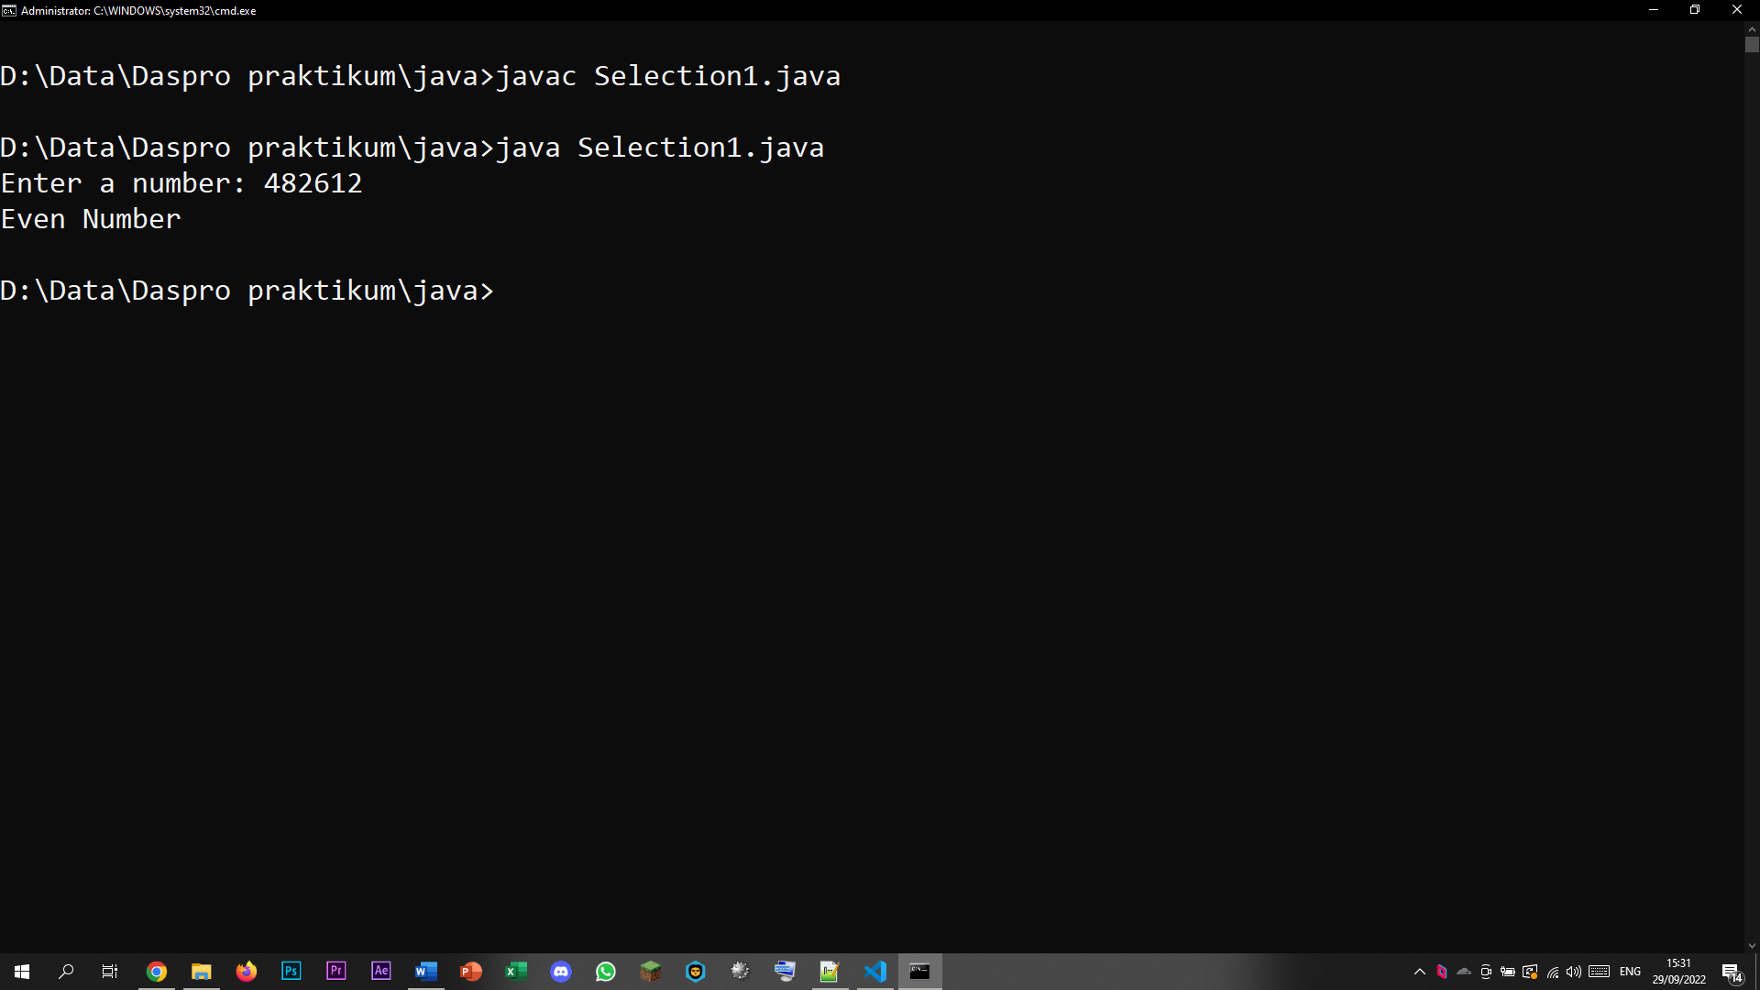

### Questions!

1. Modify the program in its selection structure so that it becomes as follows: 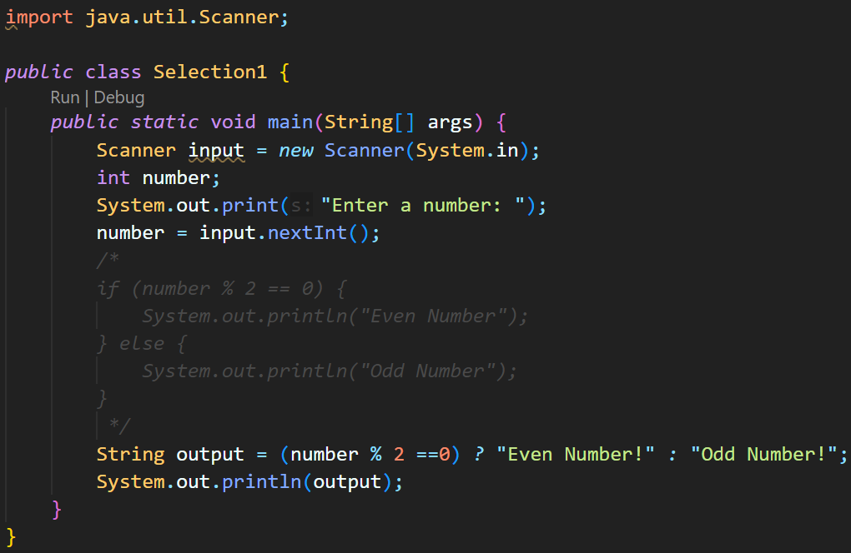
2. Compile, run, and observe the results!
3. Explain why the modified program output is the same as the program output before it was modified!

### Answer!

1. _
2. _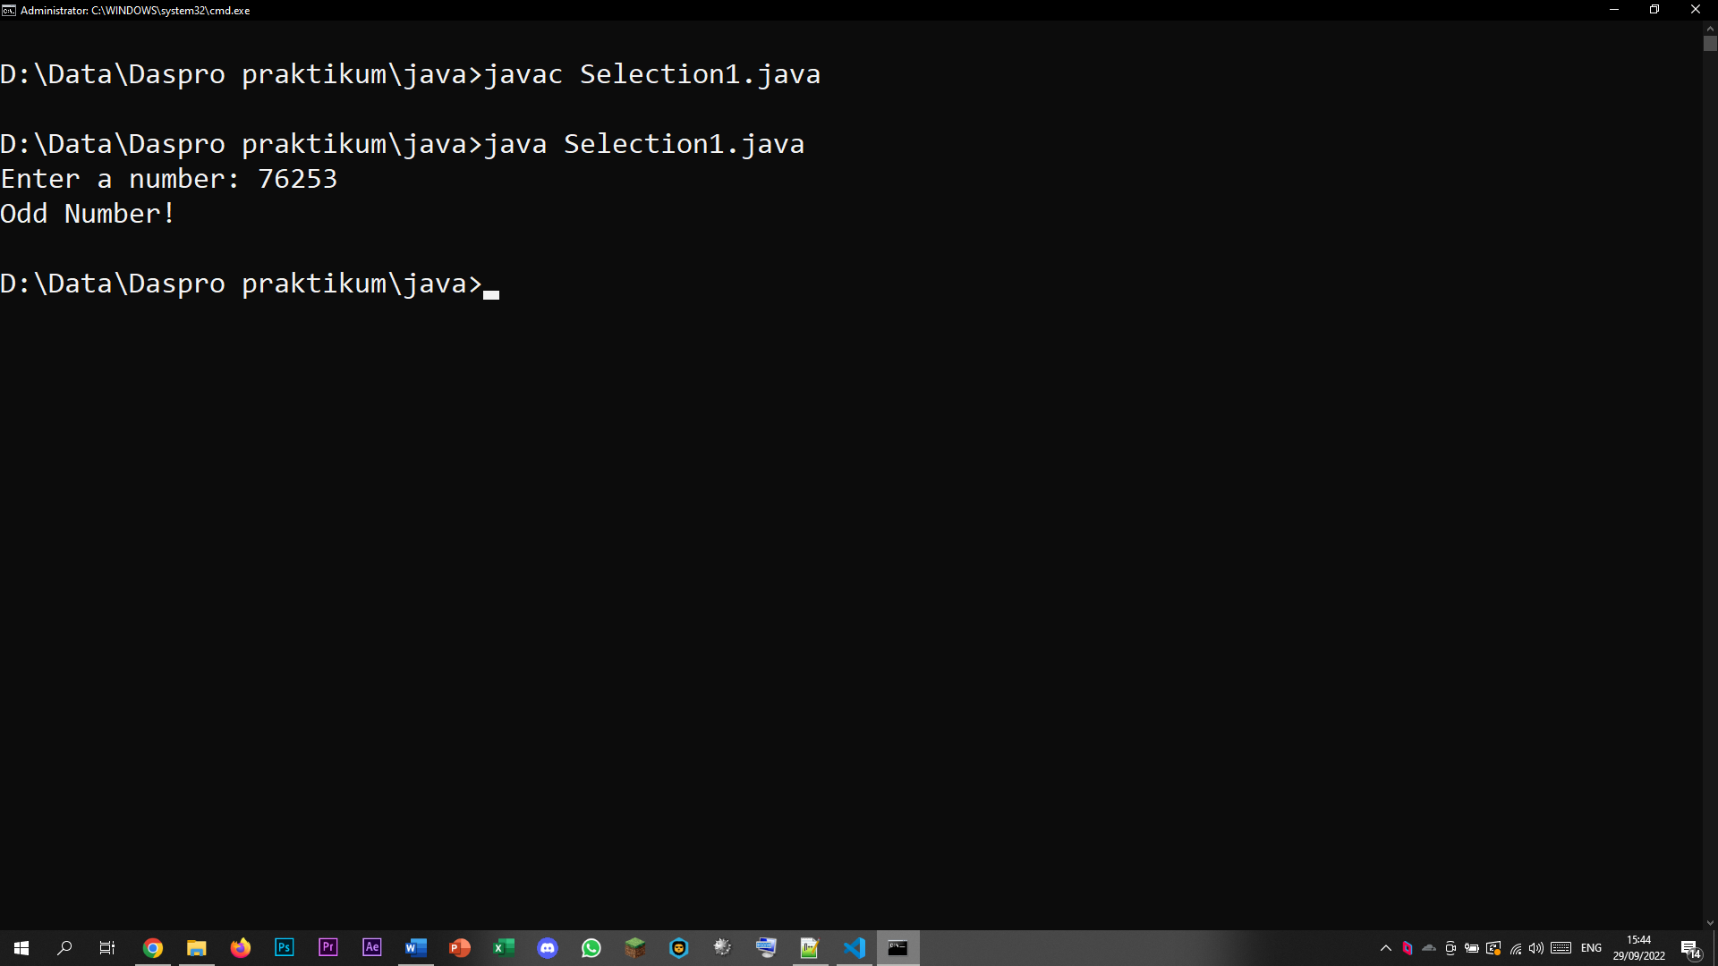
3. Because the output variable is defined as Ternary Operators which used as a selection syntax.

## Experiment 2

1. Open a text editor. Create a new file, name it Selection2.java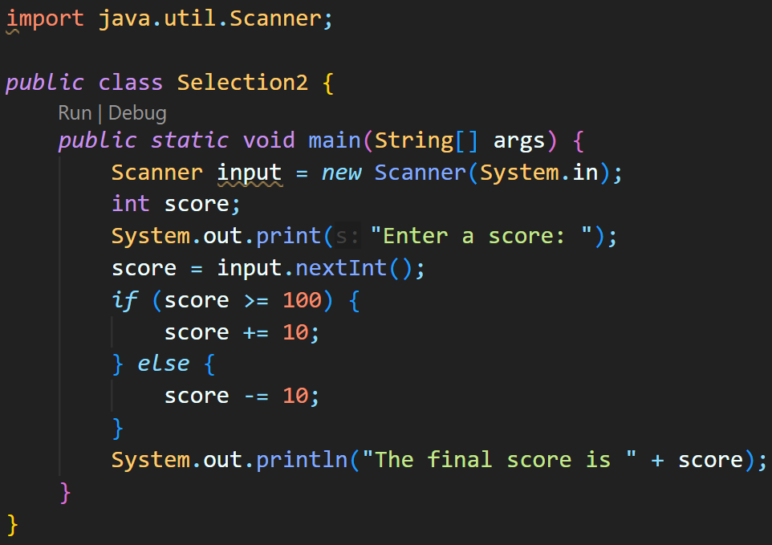
2. Write the basic structure of the Java programming language which contains the main() function
3. Add the Scanner library. Write the following code at the top outside the class 
4. Make a Scanner declaration. Write the following code in the main() function 
5. Create an int variable with the name score 
6. Write down the syntax for entering the value from keyboard
7. 
8. Add the following selection structure
9. Compile and run the program. Observe the results! 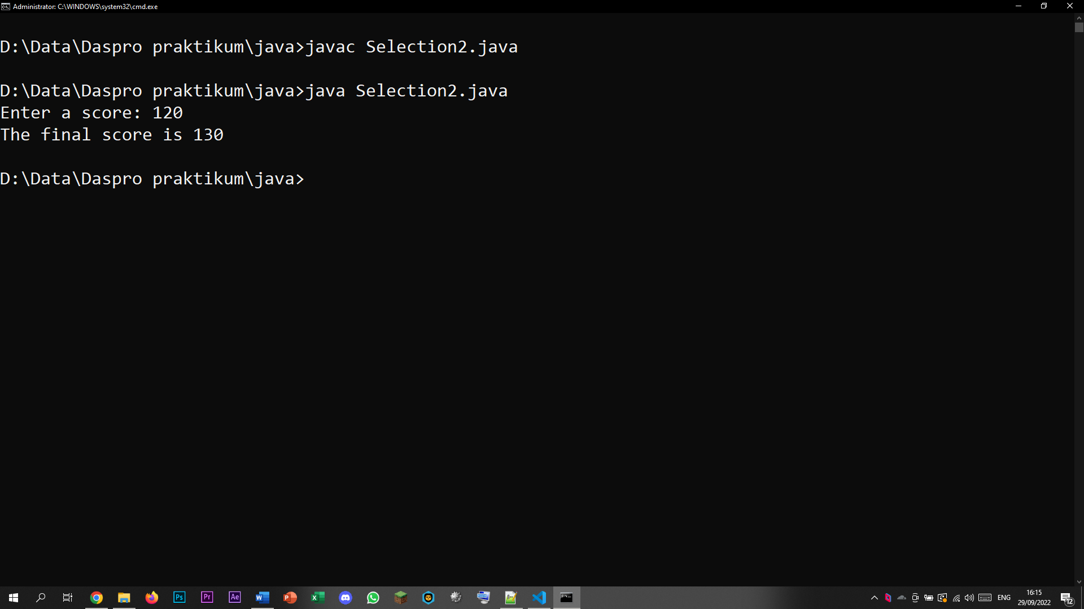

### Question!

1. Describe the function of the following program code:

score += 10;

score -= 10;

1. Modify the program so that only one input becomes two (for example: score1and score2). Then calculate the average of the two values, if the average value is more than equal to 100 then subtract 5, whereas if the average value is lessthan100 then it will be printed immediately!

### Answer!

1. To add/subtract 10 from the initial score
2. _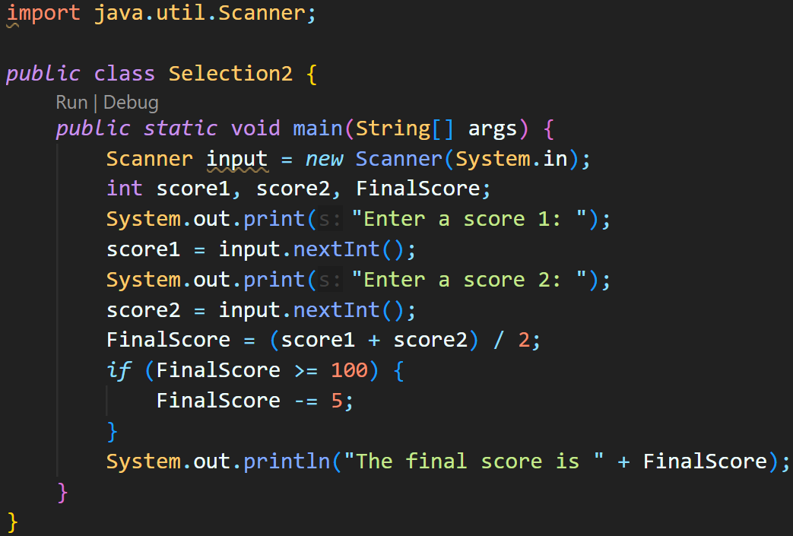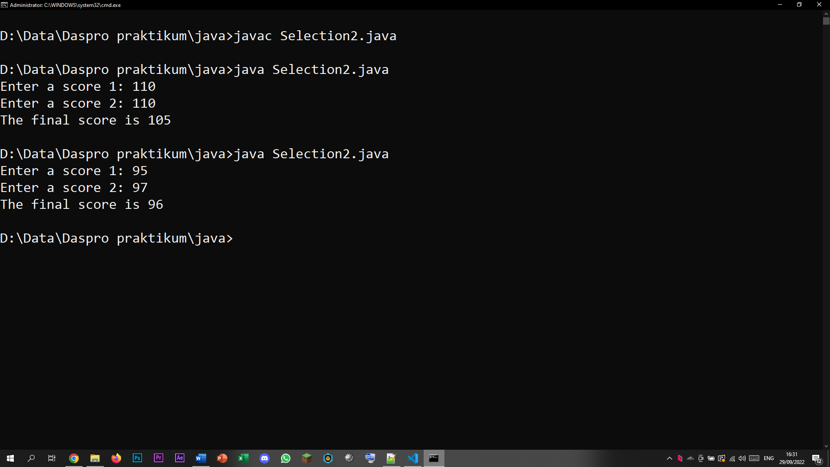

## Experiment 3

1. Open a text editor. Create a new file, name it Selection3.java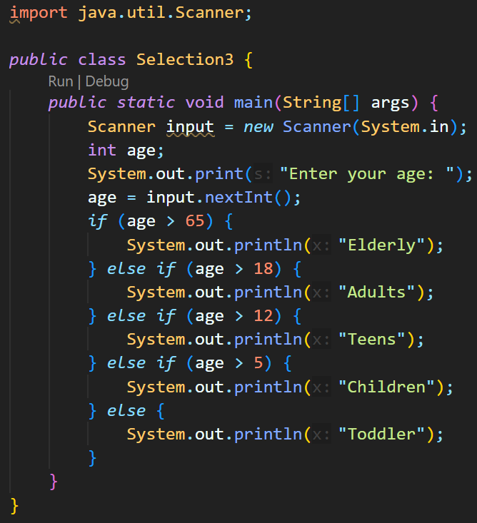
2. Write the basic structure of the Java programming language which contains the main() function
3. Add the Scanner library. Write the following code at the top outside the class 
4. Make a Scanner declaration. Write the following code in the main() function 
5. Create an int variable with the name age
6. Write down the syntax for entering the value from keyboard
7. Add the following selection structure to check the age category
8. Compile and run the program. Observe the results! 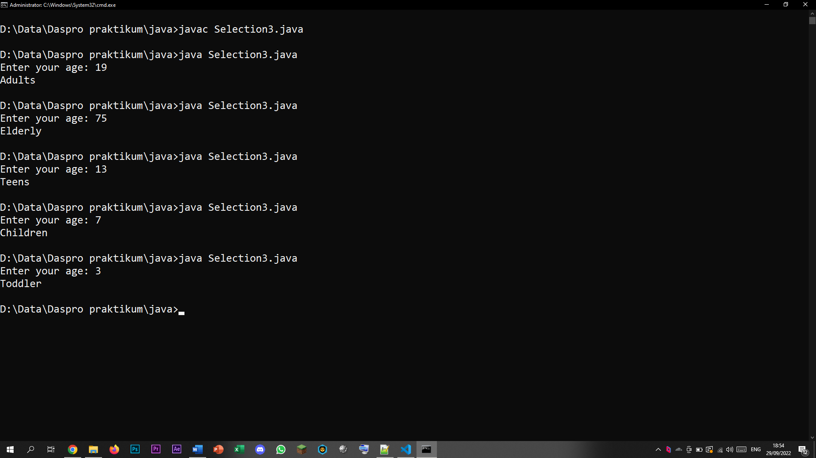

### Question!

1. How many conditions exist in experiment 3? Mention what the conditions are!
2. Modify the program so that if the age entered is 0 years or less than 0 it will display the output "Sorry, the age you entered is wrong"!

### Answer!

1. There are 4 conditions, if the age is bigger than 65, 18, 12, 5 (technically its 5 if the last else condition was also counted)
2. _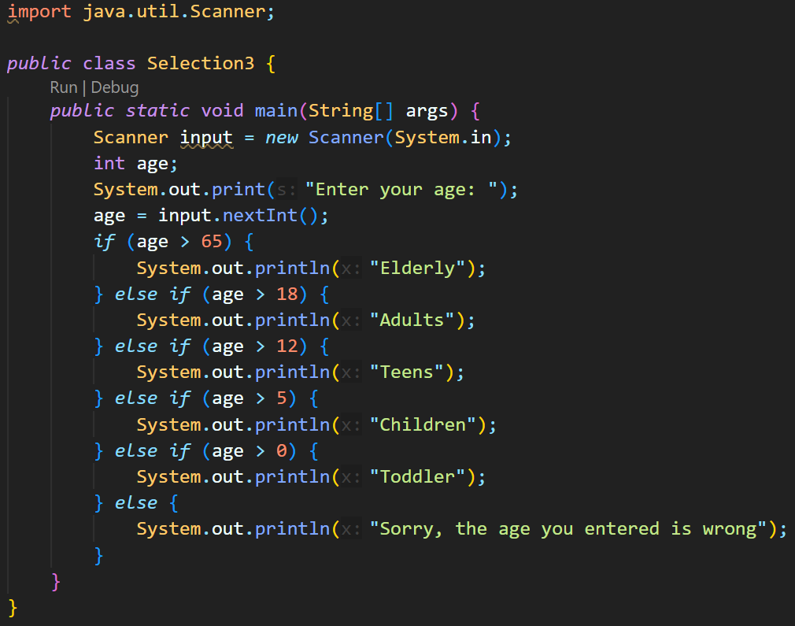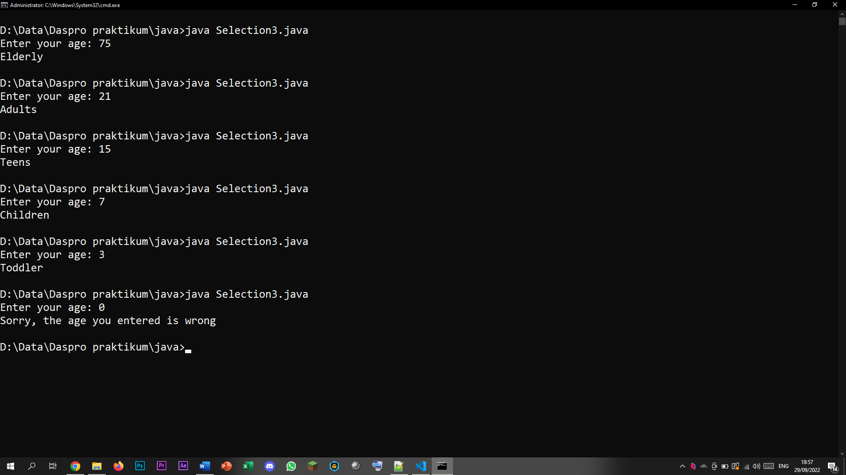

## Experiment 4

1. Open a text editor. Create a new file, name it Selection4.java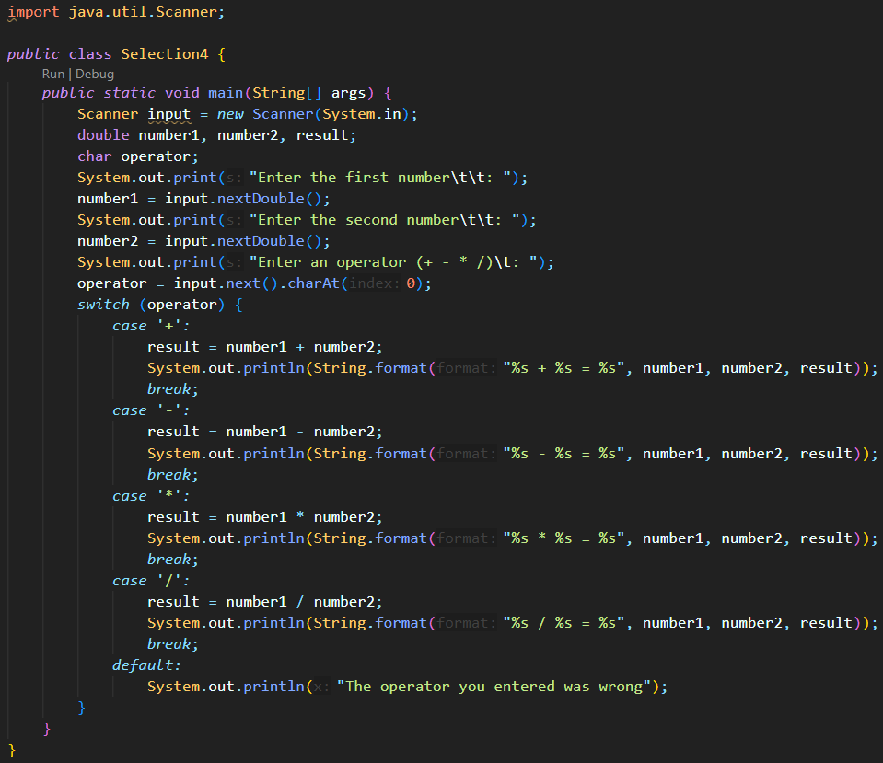
2. Write the basic structure of the Java programming language which containsthemain() function
3. Add the Scanner library. Write the following code at the top outside the class
4. Make a Scanner declaration. Write the following code in the main() function
5. Create the following variables
6. Write down the syntax for entering values from keyboard
7. Add the following selection structure
8. Compile and run the program. Observe the results! 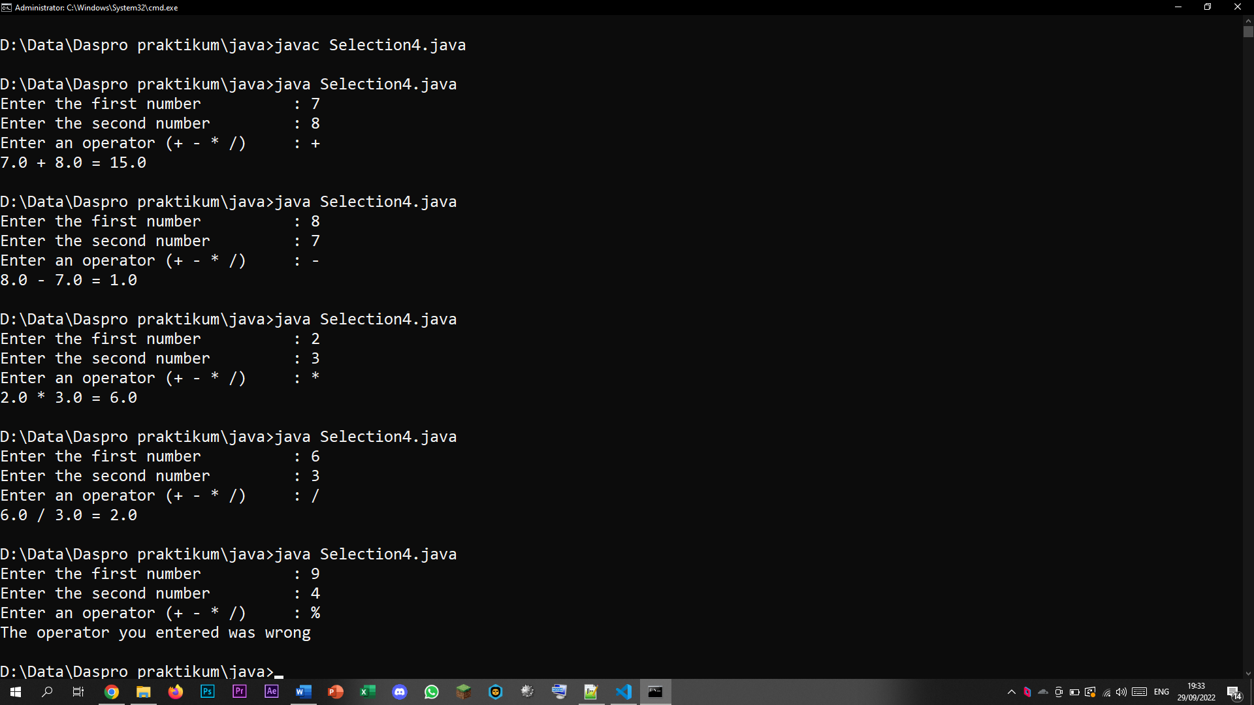

### Question!

1. Explain the function of break and default in experiment 4!
2. Explain the function of the following program code commands!

operator = input.next().charAt(0);

### Answer!

1. The function of break is to “Jump out” of a switch statement. When entering the switch function, it tries to match the correct case based on the condition. When a match condition is found, the break statement would stop the switch test process to cut down on time. The default statement would run if the switch does not find a matching condition.
2. The input is specifying to take the first character of the input specified by putting the index 0.

# Assignment

1. Create a program to input two integers, then print the one with the largest value!
2. Observe the following flowchart! 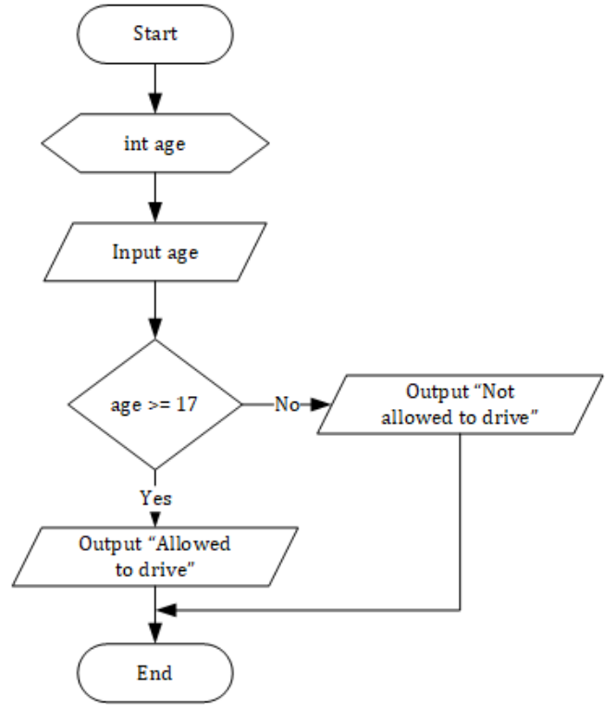 Write program code according to the flowchart!
3. At the end of the semester a lecturer calculates the final score of students which consists of midterm exam score, final exam score, quiz scores, and assignment scores. The final score is obtained from 30% of midterm exam score, 40%offinal exam score, 10% of quiz scores, and 20% of assignment scores. If the final score of the student is less than 65, then the student will get a remedy. Create a program to help determine which students get remedies based on the final score they received!

## Answer!

1. _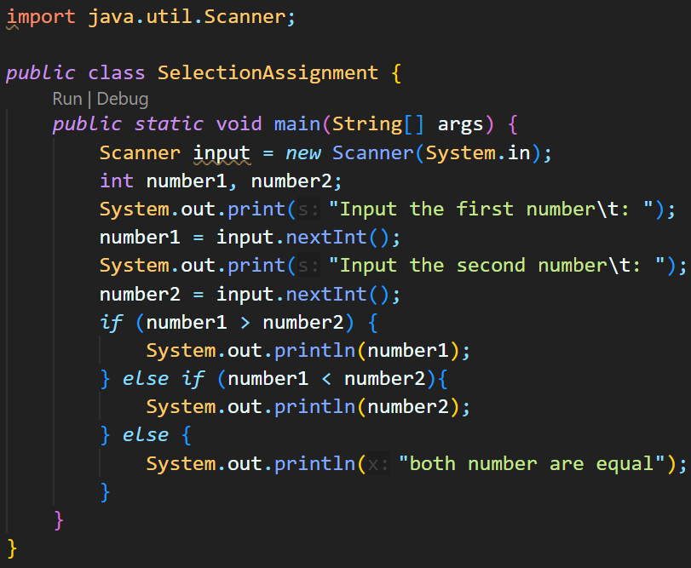
2. _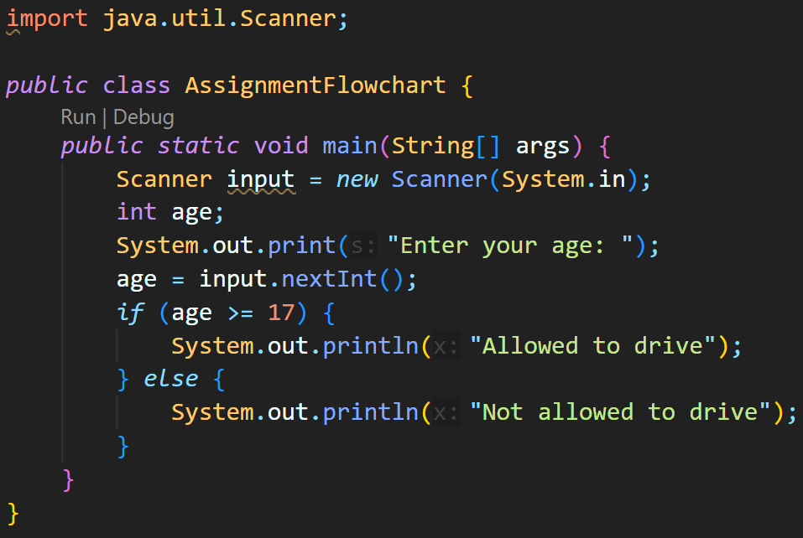
3. _